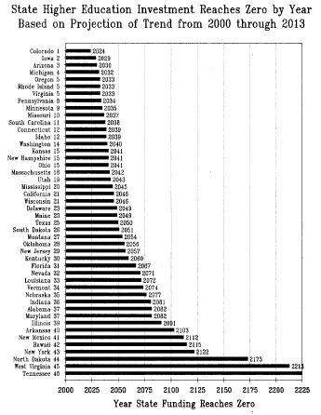

Source: Post-Secondary Education Opportunity, February 2013

<http://www.postsecondary.org/last12/248_213pg1_20.pdf>